Diffs

What Are Diffs in Version Control?
# Source: AI Source: Provided by: [Data Path: Persons Table -> ID Column: 1, Name_En Column: Motasem Essam] -> From: [ChatGPT] on [2/15/2026]
Diffs (short for differences) are the specific changes between two versions of a file — showing what was added, removed, or modified.

In Simple Terms:
# Source: AI Source: Provided by: [Data Path: Persons Table -> ID Column: 1, Name_En Column: Motasem Essam] -> From: [ChatGPT] on [2/15/2026]
A diff tells you what changed between two snapshots.
Think of it as a side-by-side comparison between an old version and a new one.

Example of a Diff:
# Source: AI Source: Provided by: [Data Path: Persons Table -> ID Column: 1, Name_En Column: Motasem Essam] -> From: [ChatGPT] on [2/15/2026]
Let's say hello.txt originally contains:
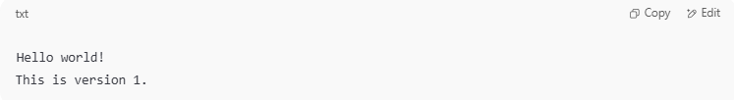
Hello world!
This is version 1.

Then you change it to:
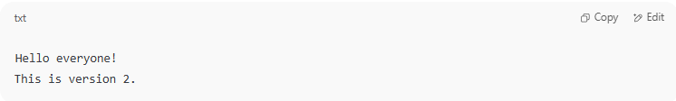
Hello everyone!
This is version 2.

The diff might look like:
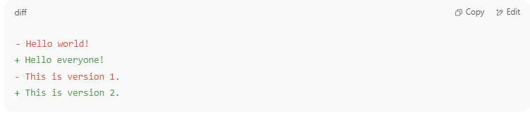
- Hello world!
+ Hello everyone!
- This is version 1.
+ This is version 2.

✅ + lines are added, - lines are removed.

Why Are Diffs Useful?
# Source: AI Source: Provided by: [Data Path: Persons Table -> ID Column: 1, Name_En Column: Motasem Essam] -> From: [ChatGPT] on [2/15/2026]
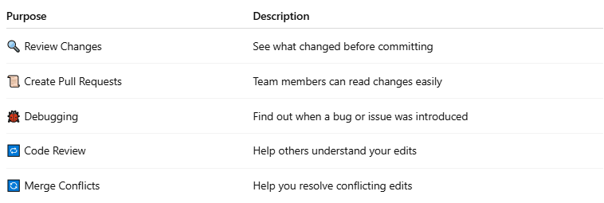

Purpose | Description
🔍 Review Changes | See what changed before committing
📜 Create Pull Requests | Team members can read changes easily
🐞 Debugging | Find out when a bug or issue was introduced
🔁 Code Review | Help others understand your edits
🔄 Merge Conflicts | Help you resolve conflicting edits

Common Diff Tools
# Source: AI Source: Provided by: [Data Path: Persons Table -> ID Column: 1, Name_En Column: Motasem Essam] -> From: [ChatGPT] on [2/15/2026]
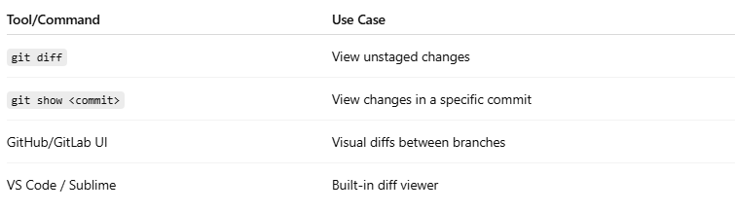

Tool/Command | Use Case
git diff | View unstaged changes
git show <commit> | View changes in a specific commit
GitHub/GitLab UI | Visual diffs between branches
VS Code / Sublime | Built-in diff viewer

Diff vs Snapshot
# Source: AI Source: Provided by: [Data Path: Persons Table -> ID Column: 1, Name_En Column: Motasem Essam] -> From: [ChatGPT] on [2/15/2026]
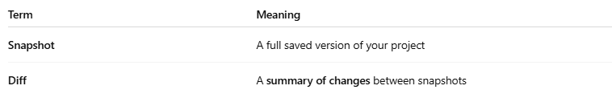

Term | Meaning
Snapshot | A full saved version of your project
Diff | A summary of changes between snapshots

Summary:
# Source: AI Source: Provided by: [Data Path: Persons Table -> ID Column: 1, Name_En Column: Motasem Essam] -> From: [ChatGPT] on [2/15/2026]
- A diff shows exact changes between two versions of a file.
- Used in version control (like Git, SVN) to track, review, and debug changes.
- Helps with collaboration, code reviews, and error tracking.

